HYPSTAT: Hydrogen Example Study Documentation

  - The case study examines the infrastructure network for hydrogen demand, production, storage, and transmission across various nodes, each with distinct characteristics and demand profiles. The demand nodes evaluated include a connection point, industrial site, city, inland area, suburb, and coastal area. Each node’s potential to support renewable energy sources—such as onshore wind, offshore wind, solar, and nuclear energy—is assessed, along with their grid connectivity, export/import capacity, and storage capabilities. The case study is designed to demonstrate the modeling capabilities of the Hydrogen Production, Storage, and Transmission Analysis Tool (HYPSTAT).
  - This documentation provides an overview of key concepts, formulas, and methodologies needed to derive essential results from HYPSTAT for hydrogen system balancing and dynamics. By analyzing direct model outputs, such as renewable, electrolyzer, transmission, and storage builds and locations, as well as by calculating Total CAPEX (Capital Expenditure), OPEX (Operational Expenditure), Levelized Hydrogen Cost (LCOH), Levelized Cost of Electricity (LCOE), and Capacity Factors for both electrolyzers and renewable resources, users can evaluate the technical and economic performance of hydrogen production facilities based on renewable energy sources and optimize the system for cost-effective, large-scale hydrogen production.

  - Case Design:

Node | Descriptor | Demand | Onshore Wind | Solar | Offshore Wind | Nuclear | Grid | Export | Import | Geologic Storage | Tank Storage
A | Connection point | NO | YES (Good) | YES (Poor) | NO | NO | YES (Wholesale, lower) | YES | YES | NO | YES
B | Industrial site | YES | YES (Good) | YES (Poor) | NO | YES | YES (Fixed industrial) | NO | NO | NO | YES
C | City | YES | NO | NO | NO | NO | NO | NO | YES(?) | NO | NO
D | Inland | YES | YES (Poor) | YES (Good) | NO | NO | YES (Wholesale, higher) | NO | NO | YES (20 kT) | YES
E | Suburb, peaker plant | YES | NO | YES (Good) | NO | NO | YES (Fixed residential) | NO | NO | NO | YES
F | Coastal | YES | NO | YES (Good) | YES | NO | YES (Wholesale, higher) | NO | NO | NO | YES

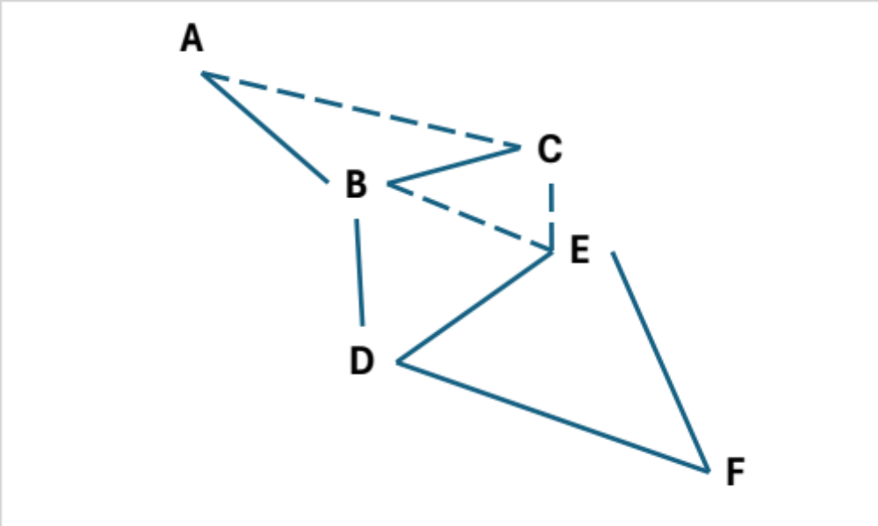
Node A (Connection Point): This node serves as a major junction in the hydrogen network, with no local demand but significant import and export capabilities. It has good onshore wind resources and modest solar potential. It connects to the wholesale grid at a lower price and has tank storage facilities.
Node B (Industrial Site): Characterized by a relatively large and flat demand profile, this site supports both onshore wind and solar (though with poor offshore wind potential). It pays a fixed industrial price, allowing it to manage stable hydrogen production and storage.
Node C (City): The city experiences medium demand, peaking in winter for heating and maintaining a consistent baseline for fleet vehicles. It lacks renewable energy resources, grid electricity, or hydrogen storage facilities to meet local H2 demand; all H2 is expected to be met by imports from other regions.
Node D (Inland): With small demand primarily for heavy-duty fuel cell electric vehicles (HD FCEVs), this node has poor onshore wind resources but good solar potential. It connects to the wholesale grid at a higher price and has significant geologic storage (20 kT) alongside tank storage.
Node E (Suburb, Peaker Plant): This node has a large demand, especially in summer for power generation. It has good offshore wind potential and a fixed residential grid connection, though it lacks geological storage.
Node F (Coastal): The coastal node features medium demand for port operations with relatively flat consumption patterns. It harnesses good offshore wind resources and is connected to the wholesale grid at a higher price. Tank storage is available, but there is no geologic storage.
  - The system network and the relative locations of each node are shown above. This structured network serves as input for potential locations and connections. The HYPSTAT evaluation aims to identify optimal configurations and strategies for hydrogen production, storage, and distribution, ensuring the lowest system-wide costs (objective function).

  - Technologies and Cost Reference:
Type | Tech | Cost Reference
Renewable | Onshore wind | NREL ATB moderate
Renewable | Offshore Wind | NREL ATB moderate
Renewable | Solar | NREL ATB moderate
Renewable | Nuclear | LCOE from H2@Scale
Renewable | Grid | NREL Cambium (Mid-case) for US national in hourly resolution (column name: ‘total_cost_enduse’)
H2 production | PEM Electrolyzer | H2A
Storage | Geologic | US number similar to NYSERDA, reference check with Jesse
Storage | Tank | US number similar to NYSERDA, reference check with Jesse
H2 Delivery | Pipeline | US number similar to NYSERDA, reference check with Jesse
H2 Delivery | Truck | US number similar to NYSERDA, reference check with Jesse

Renewable Energy: Includes onshore wind, offshore wind, solar, and nuclear energy.
H2 Production: Primarily relies on PEM (Proton Exchange Membrane) electrolyzers to convert renewable energy into hydrogen.
Storage: Hydrogen can be stored in geological formations or tanks, providing flexibility and resilience to the supply chain.
H2 Delivery: Includes pipelines and trucks, facilitating the distribution of hydrogen across various nodes and to end users.

  - Results Processing and Discussion:

1. Hydrogen Cost Calculation: Total CAPEX, OPEX, and Levelized Costs
a. Total CAPEX (Capital Expenditure)
The total CAPEX represents the upfront cost required to build and install hydrogen production facilities, including the costs of renewable energy plants, electrolyzers, storage units, and pipelines.
$$Total CAPEX= \sum{{(CAPEX}_{RE}+{CAPEX}_{Electrolyzer}+{CAPEX}_{Storage}+{CAPEX}_{Transmission )}}$$
For renewable energy (RE) systems, electrolyzers, and storage units, build costs are inputs that represent the initial cost per unit capacity (e.g., dollars per kW or kg) for each type of technology used. These costs can be derived from historical data, industry reports, or project-specific estimates. Zone Capacities is the total installed capacity in each zone, which is a direct output from the model. This capacity is multiplied by the annualized build cost, based on project finance recovery time and WACC, to obtain the annualized form of the total CAPEX for each technology.

To convert CAPEX into an annual cost, annuitize it using the Capital Recovery Factor (CRF). The CRF is based on the Weighted Average Cost of Capital (WACC) and the recovery time:

$$CRF=\frac{WACC×{\left(1+WACC\right)}^{Recovery Time}}{{\left(1+WACC\right)}^{Recovery Time}-1}$$

$$Annuitized CAPEX=CRF× Build Cost × Zone Capacity$$

For pipelines, CAPEX is determined using a cost coefficient and a power function based on the pipeline's capacity (which depends on the cost reference source). This reflects how the cost scales with capacity. The formula used is:
$${Pipeline CAPEX}_{\$/km}=pipeline cost coefficient×{{Capacity}_{Ton/day}}^{pipeline cost power​}$$
Here, the pipeline cost coefficient is a parameter reflecting the base cost, and the pipeline cost power accounts for scaling effects. The total pipeline cost is obtained by multiplying the cost per km by the total pipeline distance. To convert the total pipeline CAPEX into an annual cost, annuitize it using the Capital Recovery Factor (CRF).
b. OPEX (Operational Expenditure)
OPEX represents the ongoing costs associated with operating and maintaining the hydrogen production system. This includes fuel costs (e.g., nuclear), maintenance, and operational labor for each component, such as renewable energy sources, electrolyzers, storage units, and the transmission system. OPEX is categorized into fixed OPEX and variable OPEX.

$$Total OPEX= \sum{{(OPEX}_{RE}+{OPEX}_{Electrolyzer}+{OPEX}_{Storage}+{OPEX}_{Transmission })}$$
OPEX is typically expressed as dollars per kW or kg, or as a percentage of CAPEX (pipeline fixed OPEX), depending on the specific technology.
For trucks, the levelized cost of truck is utilized for both CAPEX and OPEX, and compression is already included in the levelized truck cost.
For compression costs, they should be accounted for twice: once for the pipeline (to increase pressure from 20 bar, as output from the electrolyzer, to 70 bar for pipeline transport) and once for storage (to increase pressure from 50-70 bar to 400 bar for storage)

c. Levelized Hydrogen Cost (LCOH)

The Levelized Cost of Hydrogen (LCOH) represents the average cost per unit of hydrogen produced, accounting for all capital and operating expenses over one analysis year. It combines both CAPEX and OPEX, divided by the total amount of hydrogen produced. For systems with access to imported hydrogen, the imported amount also bears the cost of utilizing storage and transmission infrastructure.
$LCOH= \frac{\sum{(CAPEX+OPEX)}}{Hydrogen Amount}$​

The LCOH provides a single cost metric for comparing different hydrogen production methods.

2. Transmission Infrastructure
- Transmission Buildout

The transmission infrastructure includes pipelines, trucks, and other delivery methods such as railways and marine transport (user-defined). It is required to transport hydrogen from generation sites to demand nodes or to storage units that meet hydrogen demand at various times and locations. The transmission system’s installed capacity, flow amounts, and direction at each temporal granularity are direct outputs of the model.

3. Buildout Map and Capacity (Renewables + Electrolyzers)
a. Renewable Energy Capacity

The build capacity of renewable energy (RE) sources—such as solar and wind (onshore and offshore)—reflects how the model builds dedicated off-grid resources specifically for hydrogen production. The installed capacity is the maximum amount of electricity these sources can generate within a given operating hour. This is a model output based on direct inputs. Capacity determines the total potential for renewable energy production, but actual production is dependent on the capacity factor.

b. Electrolyzer Capacity
Electrolyzer capacity dictates how much hydrogen can be produced from electricity. This capacity directly affects the hydrogen production amount and rate, which is limited by both available electricity and electrolyzer capacity. This is also a direct model output.

c. Buildout Map
The buildout map visualizes the locations of renewable energy installations, electrolyzers, pipelines, trucks (transmissions), and storage units, along with their capacities. This helps optimize the system by coordinating and reducing system-wide costs between components, ensuring an efficient supply of electricity to the electrolyzers, optimal hydrogen production and storage, and efficient hydrogen supply to demand centers. The model outputs provide all results for maps directly, including the direction of the transmission infrastructure.

4. Storage Buildout and Capacity
a. Storage Capacity
Tank storage is typically used for balancing shorter-term daily or hourly hydrogen demand. In contrast, geological storage is designed to meet longer-term seasonal hydrogen demand, with charging occurring in the shoulder season and meeting demand during peak months. Storage technologies are crucial for managing supply and demand in the hydrogen production process. Storage capacity is generally measured in kilograms (kg) or kilotonnes (kT) for hydrogen storage. These systems ensure continuous hydrogen production even during periods of low renewable generation. The storage capacity build is a direct output of the model.

5. Operating Dynamics for RE, Electrolyzers, Transmission, and Storage
a. Renewable Energy Operation
Renewable energy sources operate intermittently depending on resource availability (e.g., sunlight for solar, wind speed for wind farms). Their operation is governed by installed capacity and capacity factor. Actual energy output depends on hourly or seasonal resource availability and weather patterns. This temporal profile is a direct output of the model.

b. Electrolyzer Operation
Electrolyzers operate based on the availability of electricity from renewable sources and grid electricity (if available). Their operational efficiency and capacity determine hydrogen production. The user sets the electrolyzer efficiency as an input. This temporal profile for electrolyzer is also a direct output of the model.

c. Storage Operation
Storage systems store excess hydrogen and discharge it when required. Their operation depends on the state of charge/discharge as well as technology-specific charge and discharge limitations.

6. Levelized Cost of Electricity (LCOE) and Capacity Factors
a. Levelized Cost of Electricity (LCOE)
The Levelized Cost of Electricity (LCOE) represents the cost per unit of electricity generated by renewable sources, considering CAPEX, OPEX, and total electricity production over the analysis year.
$${LCOE}_{RE}=\frac{Total CAPEX+Total OPEX​}{Total RE electricity produced}$$

This metric is useful for comparing the cost-effectiveness of different renewable energy technologies.

b. Capacity Factor (CF)
The Capacity Factor measures the actual output of a power generation technology compared to its maximum possible output.

$${CF}_{RE}=\frac{Total RE electricity produced }{Installed Capacity×8760}$$
$${CF}_{electrolyzer}=\frac{Total RE electricity consumed }{Installed Electrolyzer Capacity×8760}$$

Capacity factors help in assessing the utilization of installed capacity and optimizing system performance.

